PERSONAL PROFILE
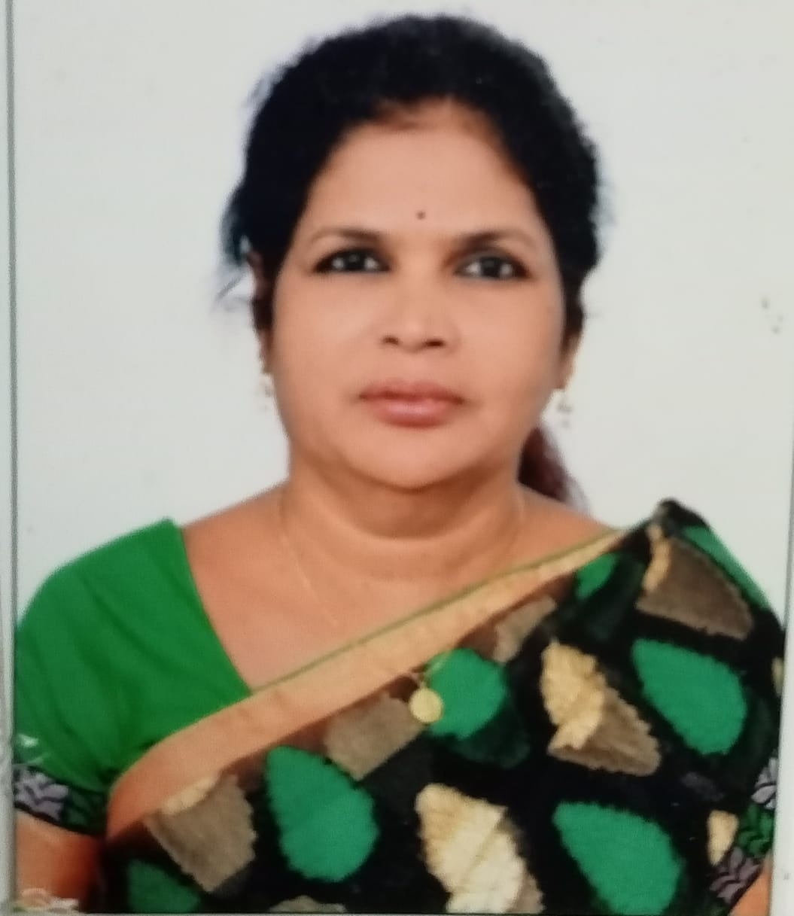

Name: G.Viswa Rani
Designation: Guest Lecturer
College Address: SRR & CVR GDC (A) Vijayawada
Cell No: 7396481148
Mail Id:gviswarani29@gmail.com

Educational Qualifications
S.NO | COURSE | BOARD / UNIVERSITY | YEAR OF PASS | PERCENTAGE
1 | M.A(Psychology) | Andhra University | 1986 | 55
2 | M.A(philosophy) | Andhra University | 1989 | 55
3 | B.A | Nagarjuna University | 1984 | 62

Professional Experience:

- Worked as Psychologist in Sri Chaitanya College for 10 Years.
- Currently Working as Guest Lecturer IN Department of Philosophy in SRR & CVR GDCA since 4 Years.

Achievements

Memberships:

In service programs attended:

Research Experience : Article published:

Conferences at International level:
.
Conferences at National level.

Conferences at State Level:

Workshops attended

Administrative Experience

